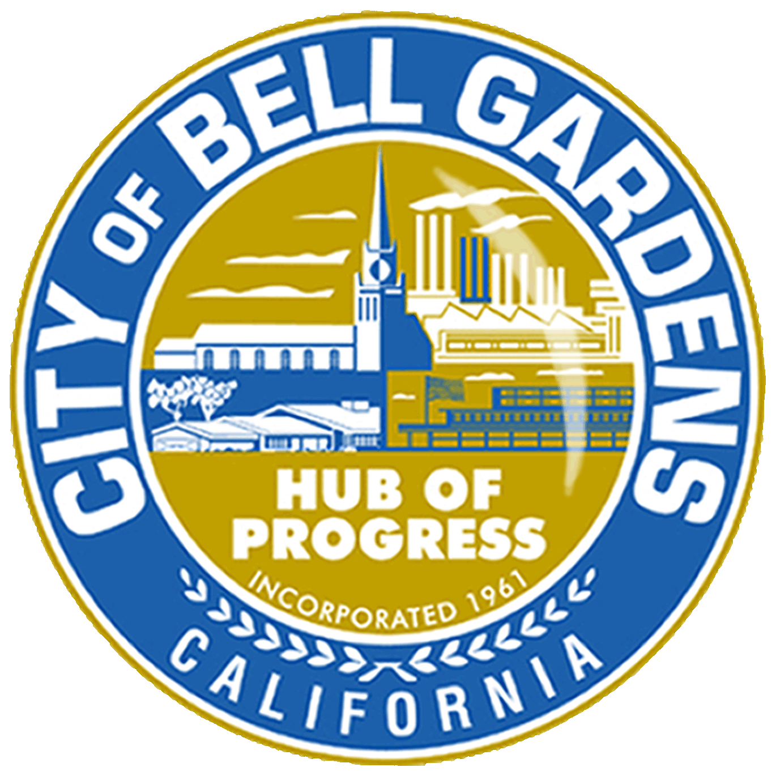

**BELL GARDENS SCHOLAR PROGRAM**

**PROGRAM GUIDELINES, APPLICATION AND ESSAY QUESTIONS**

The City of Bell Gardens will award four scholarships based on merit, leadership, academics, and other accomplishments, as proven in the written essay answers. To be eligible, students must be Bell Gardens residents in the 12th grade and maintain a cumulative GPA of 2.5 or above. Grant funds will be paid directly to the selected student. Checks will not be made out to parents.

First place will be awarded $3,000, Second place $2,000, Third place $1,000, and Honorable mention will receive $500. The scholarship is to be used towards the payment of class registration, school transportation, textbooks, and/or school supplies. Please complete the attached application and answer the (3) three essay questions. The Bell Gardens Education Commissioners and selected Recreation & Community Services team members will score and evaluate applications.

**Criteria will include but not be limited to the following:**

* Extracurricular Activities
* Employment or Community Service (volunteerism)
* Honors, Awards, and Accomplishments
* Essay, 500-word minimum
* GPA (+3 points for 3.5 GPA or above)

**On a Word document, please answer the following three questions in a**

**minimum of 500 words:**

1. How will higher education help you grow as a leader?
2. Describe a time you demonstrated leadership or overcame an obstacle.
3. Who has been your biggest inspiration, influence, or role model, and how have they mentored/inspired you to seek higher education?

**Your email should have the following attachments:**

* Application
* Copy of your school ID
* High School Transcripts
* Essay on a Word Document
* Senior Brag Sheet (Tell us all about what you do!)
* Submission due date: **Friday, May 3, 2024**

Applications must be submitted via email to [bgrecreation@bellgardens.org](mailto:bgrecreation@bellgardens.org) or dropped off at Bell Gardens Veterans Park located at 6662 Loveland Street – Monday – Friday, 9:00 am-6:00 pm. Please note the last day to submit the application is **Friday, May 3, 2024.** For additional information, please call (562) 806-7654.

**BELL GARDENS SCHOLARS PROGRAM APPLICATION**

**PERSONAL INFORMATION**

|  |  |
| --- | --- |
| First Name: |  |
| Last Name: |  |
| Home Address: |  |
| City/Zip: |  |
| Phone Number: |  |
| Email Address: |  |

**SCHOOL INFORMATION**

|  |  |
| --- | --- |
| Please select the option that best applies to you for the Fall of 2024: | |
| University  Community College  Vocational/Trade School | |
| School Name: |  |
| School Address: |  |
| City/ Zip Code: |  |

**QUALIFICATION**

|  |  |  |
| --- | --- | --- |
| Are you enrolled as a 12th-grade student? | Yes | No |
| Is your cumulative GPA at 2.5 or higher? | Yes | No |
| Is your cumulative GPA at 3.5 or higher? | Yes | No |

**Certification of Applicant:**

I hereby certify that the information I have provided in this application is true and accurate. I understand that acceptance of this initial application by the City of Bell Gardens does not constitute approval of my application. I acknowledge that providing any false information will result in my application being canceled or denied. I understand that I will be required to verify the information I have provided here and will be required to complete a full application if approved for the next stage in the application process.

The information supplied is used strictly for establishing eligibility for the Bell Gardens Scholars Program. Applicant(s) acknowledge that personal and financial information may be subject to public disclosure under the California Public Records Act. If selected for funding, the applicant(s) will be required to provide verification of school registration, proof of residency, and proof of GPA requirement.

|  |  |  |  |
| --- | --- | --- | --- |
| Signature: |  | Date: |  |

**WARNING**: The information provided on this form is subject to verification at any time. **Title 18**, **United States Code, Section1001** makes it a crime to 1) knowingly and willfully; 2) make any materially false, fictitious, or fraudulent statement or representation; 3) in any matter within the jurisdiction of the executive, legislative or judicial branch of the **United States**.

SENIOR BRAG SHEET

Please complete this form accurately, and don’t be afraid to “brag” about yourself. We will use this information as a guide to your accomplishments. You may attach a separate sheet or resumé.

|  |  |  |
| --- | --- | --- |
| Last name: | First name: | Middle name: |
|  |  |  |
| Address: | City/Zip: | Phone number: |
|  |  |  |
| Email address: | | |
|  | | |

|  |
| --- |
| What Honors/AP courses have you taken? Please list below: |
|  |
| What academic awards have you received? |
|  |
| What extra-curricular activities have you been a part of? Please list club name, position held, and years participated: |
|  |
| Please list employment and volunteer history. Please include where you volunteered and the responsibilities/duties where you were assigned: |
|  |
| What sets you apart from your classmates: |
|  |
| Name one of the accomplishments you are most proud of. |
|  |